A000-Afr-Mali-Dogon-Non-African-Figural Container-Bronze-17th c

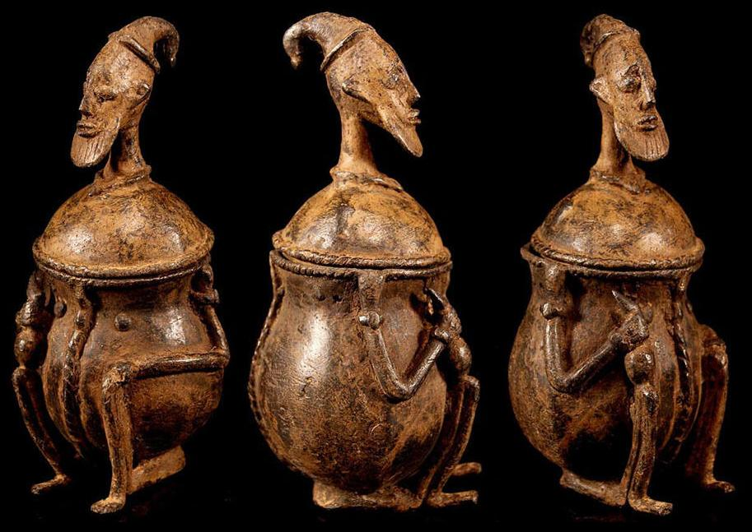

Figs. 1-3. Afr-Mali-Dogon-Non-African-Figural Container-Bronze-17th c

Case No.: 6

**Accession No.**

**Formal Label:** Afr-Mali-Dogon-Non-African-Figural Container-Bronze-17th c

**Display Description:**

**This** Non-African-Figural Container suggests the early contacts across the Sahara with peoples coming from the Nile River who brought Islam with them. This container was obviously very prized as its patina attests and it may have contained betel nut juice or some other stimulant. Its lid has a provocative likeness of an elder who holds the *baton de commandement* of his office in his right hand. He was probably an important figure of his tribal group on Mali’s bandiagara escarpment.

**Accession Number:**

**LC Classification:**

**Date or Time Horizon: 17c or earlier**

**Geographical Area:**

**Map:**

**GPS coordinates:**

**Cultural Affiliation:**

**Media:**

**Dimensions: H** 7 in

**Weight:**

**Condition:**

**Provenance:** Rarity finest old Dogon bronze Figure from the Bandiagara Escarpment

**Discussion:**

**References:**